Grouping of 49 Iranian and imported apple genotypes
Abbas Bahari¹, Hassan Hajnajari², Siamak Kalantari³, Valiollah Rasuli⁴, Sima Damyar⁵
1,3 Department of Horticulture, Tehran University, Karaj, Iran. 2,4,5 Seed and Plant Improvement Research Institute(SPII), Karaj, Iran
baharia7@gmail.com
Abstract
This study was carried out in 2007 in Karaj climatic conditions (Kamal abad research station) on some ‎Iranian and imported apple genotypes. In this research we collected data regarding fruit characteristics of 49 apple ‎genotypes. Different characters particularly pomological characters were evaluated based on Apple descriptor (Watkins and Smith. 1982). Physical and chemical tissue ‎quality were measured. Furthermore, organoleptic quality of fruits was tested by an organized panel test team. The resulting dendrogram obtained by all these characters confirmed that there were 4 distinct groups of genotypes.
In the first group there were genotypes with high weight, TSS and pH, moderately sweetness, and good sensorial analyzes. The genotypes inserted in second group had intermediate acidity, high flavor and sweetness. Third group were sour apples with high acidity, low flavor but good texture. Within the forth group we found small size and low weight apples.
Introduction:
Evaluating program on plant cultivars is a basic part of investigations in world wide universities and research centers. For this goal using different characteristics of fruit can be used. In Apple descriptor, recording different fruit characteristics is one of most important bases. For analyzing fruit data and grouping genotypes, cluster method is very useful. In this method genotypes that have more difference with others have more distance at dendrogram axis.
Material and methods:
The experiment was performed in one storage season (2007) included 49 apple genotypes. They belonged to the genotype collection of the Seed and Plant Improvement Research Institute of Iran(SPII) (Hajnajari, H. 2008). The apple trees on the seedling rootstock were 12-15 years old. The harvest time was based on the starch test. Apples were picked when their starch index reached the values from 5 to 7. The experiment was set with 10 typical fruits in each genotype taken at the time of ripeness for eating.
For the experiment, fruit characteristics include height, diameter, ratio of height/diameter, general shape, ribbing, greasiness of skin, ground color, overcolor, , length of stalk, depth of stalk cavity, depth of eye basin, russeting, total seeds, seed thickness, seed longevity and firmness of flesh measured.
Also pH, Soluble solids content (SSC) and titratable acidity (TA) were measured after firmness was determined. A peeled, wedge-shaped slice of flesh was taken from each fruit, 10 fruit wedges were pooled and juiced (O'Berne, D. 1986). pH was determined with a digital pH meter. SSC was determined by a handle refractometer (Atago, Tokyo, Japan) and TA by titration of juice to pH 8.2 with 0.1N NaOH and expressed as percentage of malic acid (Pre-Aymard, et al. 2005). Then Fruit slices accommodated to 8-12 panelists to determine their scores from 0 to 100 in special forms that separated at 10 distances. Odor, flavor, sweetness, sourness, texture, (eating quality) general acceptance, asked in these forms.
Obtained data were analyzed statistically using SPSS software and dendrogram was drawn with this software using Ward Method.
Results
Our results showed that there are distinct differences of chemical and physical characteristics among the fruits of different genotypes and can grouping the genotypes among these characteristics.
Although many of these studied genotypes have not definable ancestry and their parents are unknown but regarding with fruit characteristics and belonging to geographical areas, obtained dendrogram seems to be logical.
Regarding obtained dendrogram(shape 1): settling apple genotypes belong to same geographical areas near by others, shows that these genotypes have similar characteristics and in high probability are relationships. Also affinity of some genotypes such as ‘Akhlamad Mashad’, ‘Dir ras Mashad ‘and ‘Deraz’ is similar to Ershadi grouping in genetic investigation on 33 Iranian cultivars(Ershadi, A. 2002).

Shape 1: dendrogram of 49 Iranian and imported apple genotypes
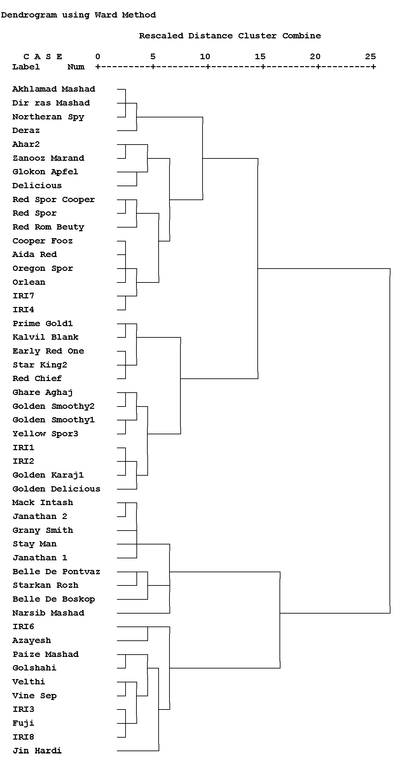
Separating of genotypes on distance 10 shows 4 distinct groups. In the first group there were genotypes with high weight, TSS, and pH, with moderately sweetness, and good sensorial analyzes. The genotypes inserted in second group had intermediate acidity, high flavor and sweetness. Third group were sour apples with high acidity, low flavor but good texture. Within the forth group we found small size and low weight apples.

References
- Ershadi, A. 2002: Study on pollination and fruit set and evaluation of Iranian apple cultivars using molecular. Tehran university.
- Hajnajari H. 2008. National Fruit Collection of Iran(Germplasm and Pomology). Horticulture Department Seed and Plant Improvement Institute Karaj-Iran
- O'Berne, D. 1986. Effects of pH on nonenzymic browning during storage in apple juice concentrate prepared from bramley's sedling apples. Journal of Food Science. Vol 51, 1073-1074.
- Pre-Aymard, C., Fallik, E., Weksler, A., Lurie, S. 2005. Sensory analysis and instrumental measurements of ‘Anna’ apples treated with 1-methylcyclopropene. Journal of Postharvest Biology and Technology. Vol36,135-142.
- Sinha, N. 2006: Apples. In: Handbook of fruits and fruit processing by Hui, Y. H., Blackwell publishing.
- Soska, A. Tomala, K. 2006: Internal quality of apples during storage. AGRONOMIJAS VĒSTIS (Latvian Journal of Agronomy) 9: 146-151.
- Watkins, R. Smith, R. A. 1982: descriptor list for apple(Mallus). IBPGR, Rome.
- Zamani, z. 1990: Investigation on most important of Pomegranate at Save and central area of Iran. Tehran university.

