Genetic relatedness and fingerprinting of apple rootstocks using microsatellite markers

Gahromee Shirazee R¹, Keshavarzi M^{2*}, Naghavi MR³, Damyar S², Hosainee Zavarei M¹, Hassani A⁴

¹Science and Research Branch of Islamic Azad Univ, Tehran, Iran
²Seed and Plant Improvement Institute, Karaj, Iran, mansureh_1343@yahoo.com
³Biotechnology Dept, College of Agriculture, Tehran Uuniv, Karaj, Iran
⁴College of Agriculture, Gillan Univ, Iran

ABSTRACT
In recent years, application of molecular markers for DNA fingerprinting in cultivated plants have been increasingly advanced. This advantage is particularly important in woody perennials due to some characteristics of these species including their long generation time, large individual size and their vegetative propagation. In this research, 5 previously described SSR markers were evaluated for potential use in fingerprinting and determination of genetic relatedness between MM106, MM111, M9, B9 and Azayesh rootstocks. Based on the result, 43 reproducible alleles were produced in five SSR loci (average 8.6 allele per locus) among which, 12 alleles were rootstock-specific. A concordance was verified to exist between the grouping and parental source. Using this method, all cultivars were easily distinguishable and it is proposed that all commercial apple rootstocks be fingerprinted to provide an accurate and reliable data for production of certified material.

KEYWORDS: apple, microsatellite, rootstock, fingerprinting.

INTRODUCTION
The production of certified plant material in fruit and nut tree species requires the application of fast and reliable technique to identify both old and new genotypes (WÜnsch and Hormaza, 2002). Identification of apple rootstocks based on visual morphological characteristics is often difficult because of the genetic similarity between many rootstocks and the restriction of observable characteristics at the nursery stage and the effect of environmental condition on morphological traits (Oraguzie et al., 2005). DNA markers are a useful tool for selection and gene introgression when they are linked to genes of interest , for the construction of genetic maps and the study of the similarity and the genetic distance among them. Among any kind of DNA markers can be used for fingerprinting fruit tree species, the most widely used have been RAPDs, RFLPs, AFLPs and more recently, SSRs and ISSRs (WÜnsch and Hormaza, 2002). SSR markers have been proven to be highly informative and useful for distinguishing genotypes and for determining genetic relatedness among Malus cultivars and species (Galli et al., 2005). In this study, the potential of six previously described SSR markers (Guilford et al., 1997; Gianfranceschi et al., 1998) for identification and genetic relatedness of five local and commercial apple rootstocks was studied.

MATERAL AND METHODS
Five Malus spp. rootstocks including MM106, MM111, M9, B9, and a local rootstock, Azayesh were utilized. The total DNA was extracted isolated from young fresh leaves using the CTAB method. Five pares of microsatellite primers (05G8, 02B1, CHO2B10, CHO2D12, CHO1HO1) were used and sequences are described in Guilford et al. (1997), and Gianfranceschi et al. (1998). The amplification reactions were conducted in a Corrbet thermocycler in a 25 µL volume containing 5 ng of DNA, 10 mM Tris-HCl pH 9, 0.2 mM of each dNTP, 1.5 mM MgCl₂, 50 mM KCl, 0.2 µM of forward and reverse primers and 1U of Taq DNA polymerase. The program used in the PCR reactions consisted of one cycle at 95ºC for 3 min, 30 cycles at: 95ºC for 30s, 55-57ºC for 60s and 72 C for 60s, followed by a final cycle at 72ºC for 10 min. Optimal annealing temperatures for each primer pair was determined with touch down PCR. Of the amplified samples, 4.5µl were applied in a 6% polyacrylamide gel, in 1XTBE buffer and gels stained with silver nitrate staining method. The amplification products visualized in the gels were recorded with regard to the presence (1) or absence (0) of bands and the dendrogram was prepared using the Unweighted Pair Group Mean Average method (UPGMA) using NTSYS.pc software.

RESULAT AND DISCUSSION
In our condition, the annealing temperatures for 05G8, CH02B10, CH02D12, 02B1 and CH01H01 was determined as 56, 63.5, 60.5, 59.5 and 56.5 ºC, respectively. All five SSR markers were polymorphic and revealed a total of 43 alleles in five SSR loci (average 8.6 allele per locus) and 11 polymorphic bonds sufficient to characterize all genotypes (Table 1). Two polymorphic bonds were obtained with 05G8, and CH02B10T, CH02D12, 02BB and CH01H01 produced 3, 3, 1 and 3 polymorphisms each, respectively (Figure 1). This result is confirmed by Oraguzie et al. (2005) which using seven SSR markers distinguished 66 clonal apple rootstocks.
The dendrogram constructed with data from the five primers allowed the five rootstocks to be clearly separated (Figure 2). According to this grouping, concordance was verified to exist between the grouping and parental source, but not with geographical origin. MM111 and MM106 which have Northern Spy as one of their parents in breeding programs, were placed in a single group while other rootstocks with no common parent, were clearly separated in different groups.

Table 1. Allele sizes in base-pair of 5 SSR loci distributed on 5 tested apple rootstocks.
Rootstock
MM₁₀₆ | M₉ | MM₁₁₁ | B₉ | Azayesh | Marker
- | - | - | 177 | 182 | 05G8
122 | 126 | - | - | 139 | CH02B10
- | 207  200 | - | 198 | - | CH02D12
- | 212 | - | - | - | 02B1
- | - | 107  405 | - | 123 | CH01H01

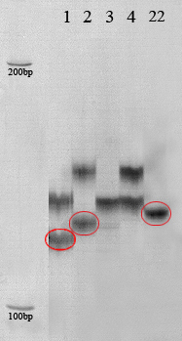 | 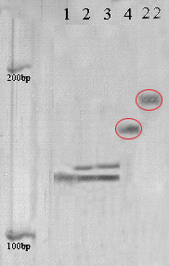
Figure 1. Amplification products generated by microsatellite markers 05G8 (left) and CH02B10 (right) for Malus spp. Rootstocks MM106 (1), M9 (2), MM111 (3), B9 (4) and Azayesh (5). Left columns, 100 bp marker.

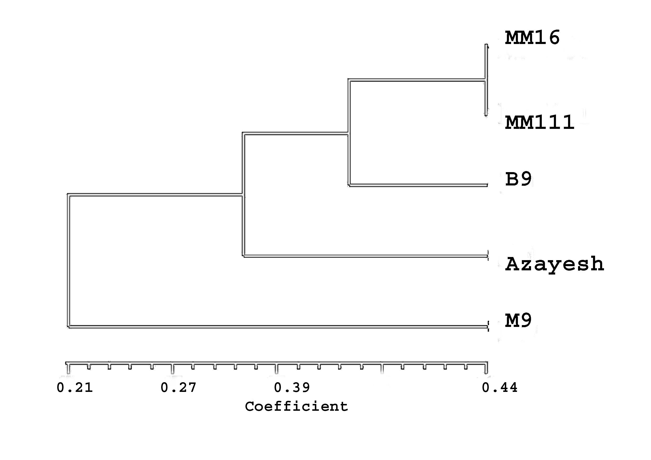
Figure 2. UPGMA dendrogram based on Dice similarity index, representing relationship among 5 apple rootstocks analyzed by SSR markers.

REFERENCES
Galli Z, Halasz G, Kiss E, Haszky L (2005). Molecular identification of commercial apple cultivars with microsatellite markers. Hort Sci 40:1974-1977.
Gianfranceschi L, Seglias N, Tarchini R, Komjanc M, Cgessler C (1998). Simple sequence repeats for the genetic analysis of apple. Theor Appl Genet 96:1069-1076
Goulao L, Cristina M (2001). Molecular characterization of cultivars of apple (Malusdamestica Borkh) using microsatellite (SSR and ISSR) Markers. Euphytica 122: 81-89.
Guilford P, Sprakash Zhu JM, Rikkering E, Gardiner S, Bassett H, Forster R (1997). Microsatellite in Malus damestica (apple): abundance, polymorphism and cultivar identification. Theor Appl Genet 94:249-254.
Oraguzie NC, Yamamoto T, Soejima J, Suzuki T, De Silva HN (2005). DNA fingerprinting of apple (Malus spp.) rootstocks using simple sequence repeats. Plant Breed 124: 197.
WÜnsch A, Hormaza JI (2002). Cultivar identification and genetic fingerprinting of temperate fruit tree species using DNA markers. Euphytica 125: 59-67

