The Karyological Study of Some Amygdalus spp in Iran
R.Tavakoli , ²Imani A., ³Hoseinava S. ⁴Zarifi E., ⁵ Jafaraghaie M. And ⁶ Mohammadi A.
^{1,6}Plant Breeding Department of Karaj Islamic Azad University, Iran,
A.O. Box1351898379 Tehran, Iran
^{2,3,4,5}Horticultural Department of Seed and Plant Improvement Institute (SPII),
A.O. Box31585-4119 Karaj, Iran
Abstract. Karyotypes of four domestic and wild almond species with peach including Amygdalus communis L., A.orientalis Duh, A. eleaegnifolia Spach, A.lycioides Var. lycioides Spach and A. persica L., were studied. The meristem cells of the root was used for these studies. The standard karyotype was prepared for the species separately and the the chromosomes parameters including the total length of the chromosomes, long arm, short arm, arm ratio, and centromer index were calculated. There was significant difference between all of the species that can be employed to recognize the species. All of the studied species were diploid with the numbers of the chromosomes 2n=16 and the base number of the chromosomes was X=8. Avarage size of chromosomes in this genus species was 2.47± 0.02 µm in Iran. Also there was significant difference between all of the homologous chromosomes according to the measured cytological characters. In this study, for species classification was used cluster analysis. It was fond that A.communis L. had the most similarity with A. A.orientalis Duh and A.lycioides Var. lycioides while A.persica L. and A. eleaegnifolia Spach had the most similarity with each other. In finally, For each species was determined a key to identify. Also the study species were classified two groups cytologically.
Keywords: Cytogenetic, Almond species, Peach, Chromosome
Introduction
Almond species and peach are belonging to the subfamily Prunoideae of the family Rosaceae. Peach is classified with the almond species in the subgenus Amygdalus within the genus Prunus, distinguished from the other subgenera( prunuphora and cerasus sections ) by the corrugated seed shell (Hese, 1971). Iran is especially rich in native germplasm of these wild species, that are naturally distributed throughout the country (Sabeti 1994; Sorkheh et al. 2009). Recent studies have been performed using morphological, protein and molecular markers for the genetic characterization of these Iranian wild Prunus species (Martinez-Gomez et al. 2003; Shiran et al. 2007; Sorkheh et al. 2007; Zeinalabedini et al. 2008; Depypere et al. 2009; Tavakoli et al. 2010). However there is no report on cytogenetical characteristics of wild almond species in the literature review not only in Iran but also in other countries. More recently, Martinez-Gomez et al. (2005) are reviewed the chromosome studies in Prunus species and presented an improved technique for counting chromosomes in almond (Martinez-Gomez et al. 2005). The other studies on wild almond species in Iran showed all of their were diploid (2n=16) (Tavakoli et al. 2010; Yousefzadeh et al. 2010). The objective of this work was to report an easy and evaluated some karyotypic characters in several Iranian wild species.
Materials and Methods
The plants materials include Five plant species such as Amygdalus communis L., A.orientalis Duh, A. eleaegnifolia Spach, A.lycioides Var. lycioides Spach and A. persica L. collected from the different parts of Iran. The first step in the cytogenetic studies was having the meristem cells from the new and suitable root tips. After providing the meristems of the root tip from the germinated seeds radicle, they were treated by the 8-hydroxy quinolin (0.002 molar) solution for 3 hours inside the refrigerator in 4˚C. Then, they were placed in the solution of Lewitsky (one part chromic acid 1% and one part formaldehyde 10%) for 36-48 hours in 4˚C (Lewitsky,1931). For roots hydrolysis was used hydroxide sodium (1N). Then for staining was used aceto iron hematoxline (Agayev,2002). Then the specimen was preserved in 30_35 ˚C for 16 hours. The Cytase was used to solve the cells wall for 2 hours in the temperature of the room. Finally, in the stage of the squash, samples preparation to photography. Then some photos selected for karyotypic characters measuring by Micro Measure (version 3.3) Software (Reeves 2001) to determine chromosomes length and then analyzed by SPSS® 16.0 software.
Results and Discussion
Regarding the plant material assayed, in this study to determine of the chromosome numbers and karyotypic parameters of wild almond species has been used mitotic material of root tips. Our results also showed that secondary roots were containing more metaphase cells number and stained better than primary roots. The disadvantage of primary roots probably was due to thickness and fatty acid containing preventive of suitable influence of the materials penetration in cellular tissue through karyotype procedures. Pictures in Figure 1 illustrate examples of the chromosomes encountered for each of the Amygdalus communis L., A.orientalis Duh, A. eleaegnifolia Spach, A. persica L. and A.lycioides Var. lycioides Spach species. The 5 wild almond and peach species investigated cytological for the first time were diploid and showed 2n=2x=16 in all cells examined. This chromosomes number is the most frequent for the genus and agreeing with previous reports in other almond species (Martinez-Gomez et al. 2005; Tavakoli et al. 2010; Yousefzadeh et al. 2010). In study of A.communis L., from total 8 of chromosomes (pair), one chromosome was big. Satellites were available on one chromosome and they are located at the end of short arm of chromosome of number two (Tab.2, Tab.3, Fig.2). Although chromosome complement of this species was reported as symmetric with a predominance of metacentric chromosomes(Martinez-Gomez et al. 2005). In study of A. orientalis Duh from total 8 chromosome, one big chromosome observed. Satellites are available on one chromosome and they are located at the end of short arm of chromosome of number two (Tab.2, Tab.3, Fig.2). In study of A. eleaegnifolia Spach from total 8 chromosome, one big chromosome observed. Satellites are available on two chromosome and they are located at the end of short arm of chromosome of number two and three (Tab.2, Tab.3, Fig.2). this results for A. eleaegnifolia Spach conforms with Yousefzadeh et al. (2010), but we observed two satellite on the chromosomes. In study of A. persica L. from total 8 chromosome, one big chromosome and one small chromosome were observed. Satellites were available on one chromosome and they are located at the end of short arm of chromosome of number two (Tab.2, Tab.3, Fig.2). In study of A. lycioides Var. lycioides Spach from total 8 chromosome, two small chromosome and two big chromosome were observe. Satellites are available on one chromosome and they are located at the end of short arm of chromosome of number two (Tab.2, Tab.3, Fig.2).
Tab.2 chromosome number and Karyotype description of the examined Almond on based Levan's method (Levan, 1964)

Species | Somatic number | Karyotipic Description | Lengh range
A.communis L. | 2n=2x=16 | 5m+1m(sc)+2sm | 1.51-2.68
A.eleaegnifolia Spach | 2n=2x=16 | 6m+2m(sc) | 1.5-3.67
A. lycioides Var. lycioides Spach | 2n=2x=16 | 6m+1m(sc)+1sm | 1.49-3.70
A.orientalis Duh | 2n=2x=16 | 6m+1m(sc)+1sm | 1.42-2.92
A. persica L. | 2n=2x=16 | 6m+1m(sc)+1sm | 1.83 -3.58

Tab.3 Morphometric parameters of the karyotypes in the almond species
Species | haploid complement | Long Arm | Short Arm | Arm Ratio | Centromer index(CI) | L% | S%
 |  |  |  | (L/S) | Centromer index(CI) | L% | S%
A.communis L. | 15.36 | 1.92 | 1.09 | 1.39 | 42.82 | 56.8 | 43.2
A.eleaegnifolia | 20.64 | 1.29 | 1.08 | 1.56 | 41.05 | 54.2 | 45.7
A. lycioides Var. lycioides Spach | 17.92 | 1.21 | 1.03 | 1.31 | 44.54 | 54.02 | 45.9
A.orientalis | 16.24 | 1.08 | 0.96 | 1.24 | 45.32 | 53.2 | 46.8
A. persica L | 19.92 | 2.49 | 1.43 | 1.44 | 42.28 | 57.4 | 42.5
L/S= Largest/shortest chromosome;CI= Centromeric Index; L%= long arm percent; S%= short arm percent

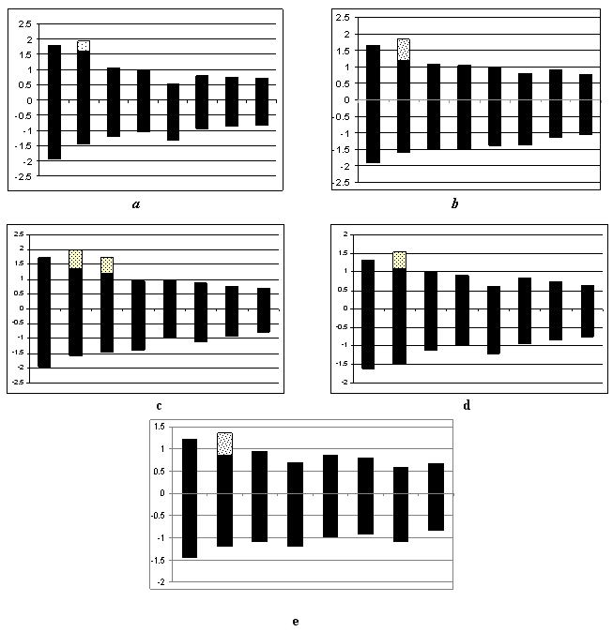 Fig.1Miotic metaphase idiogram of Amygdalus spp including a) A. eleaegnifolia Spach, b) A. orientalis Duh, c) A.lycioides Var. lycioides Spach, d) A. communis L. and e) A. persica L. that the satellites are shown spotter

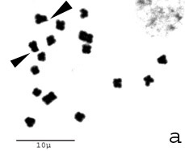
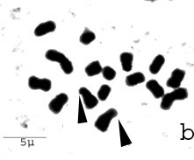
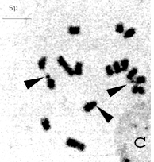

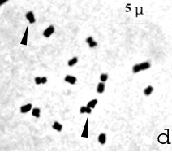
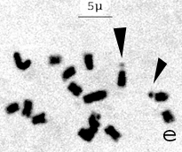

Fig. 2 Miotic metaphase of Amygdalus spp including, a) A. communis L, b) A. persica L.. c) A. eleaegnifolia Spach, d) A.lycioides Var. lycioides Spachand and e) A. orientalis Duh that the chromosomes satellites shown by arrows

Chromosomes type used as a key to the distinction of study species in terms of centromer location, chromosome length and the number of satellites to study the species are also included(Tavakoli et al. 2010). A. communis L. had contain two sub metacentric chromosome pairs while the A.orientalis Duh, A. eleaegnifolia Spach, A. persica L. and A.lycioides Var. lycioides Spach, had a sub metacentric chromosome pair. In A. persica L. Species had five sub metacentric of chromosome pairs while the A.orientalis Duh, A. eleaegnifolia Spach and A.lycioides Var. lycioides Spach species had six metacentric chromosome pairs. A. eleaegnifolia Spach had two satellite chromosome pairs while the A.lycioides Var. lycioides Spach and A.orientalis Duh species had a satellite chromosome pair. A.lycioides Spach chromosomes has longer than A. orientalis Duh species.
To group the studied species on the basis of the considered traits (total length of the chromosome, long arm, short arm, arms ratio and centromer index), the method of cluster analysis has been used. The cluster analysis from 5 species has been showed in the figure 3. Dendrogram from the cluster analysis has been obtained using Ward's Method detected that the studied species were separated in two different groups. In the first group situated A.persica L., A. eleaegnifolia Spach and in the second group A.communis L., A.orientalis Duh and A. lycioides Var. lycioides Spach, were placed (Fig.3). According to Duncan test comparison method A.persica L. and A. eleaegnifolia Spach are for centromeric index and arm ratio traits in a subset and about the other traits, total length of the chromosome, long arm and short arm the also are arranged near each other subsets. Also this group had longer chromosome than other group. In A.lycioides Var. lycioides Spach, A.orientalis Duh and A.communis L., for the most traits like the total length of the chromosome, long arm, short arm and centromeric index have been near each other subsets that show the chromosomal similarity between the chromosomes of these three species (Tab.4). By comparing the total length of the chromosome, long arm , short arm, it was found that three species had a satellite chromosome. According to the above traits relative to the species of the another group they were shorter chromosome size.
Tab.4 The comparison of the studied spesies on the basis of the studied chromosome trairts
Species |  | Subset
 | Total lenght |  | Long Arm | Short Arm | Arm Ratio | CI
Amygdalus communis L. |  | 1.92 a | 1.09 a | 0.82 a | 1.39 b | 42.82 a
A.orientalis Duh |  | 2.03 b | 1.08 a | 0.96 b | 1.24 a | 44.5 a
A. lycioides var. lycioides Spach |  | 2.24 b | 1.2 b | 1.03 c | 1.31ab | 44.1a
A. persica L. |  | 2.49 d | 1.43 c | 1.06 cd | 1.44bc | 42.4 a
A.eleaegnifolia Spach |  | 2.37 c | 1.29 b | 1.08 d | 1.56 c | 43.05a
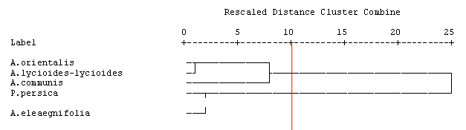

Fig.3 Dendrogram of studied species base on ward method.
Results of chromosomal studies have proven useful in plant taxonomy and phylogenetic analysis. In this sense, our results indicated the closer genetic and evolutionary distance between A.lycioides Var. lycioides Spach, A.orientalis Duh and A.communis L. in comparison with A. persica L., A. eleaegnifolia as has been described using morphological, protein and DNA markers (Zeinalabedini et al. 2008; Shiran et al. 2007; Sorkheh et al. 2007). The similarities observed between species in this karyotype study suggests a high level of synteny within the Prunus genus (Arus et al. 2006) and should also facilitate the successful transfer of genetic information through interspecific hybridization described by Sallesses and Bonherta (1993). In addition, these results of chromosomal studies may be also useful in phylogenetic analysis in Prunus species (Singh et al. 1984; Soodan et al. 1988) complementing morphometric and molecular studies (Martinez-Gomez et al. 2003; Depypere et al. 2009).
REFERENCES
AGAYEV Y.M., 2002— New features in karyotype structure and origin of saffron, Crocus sativus L. Cytologia, 67: 245-252.
ARÚS P., YAMAMOTO T., DIRLEWANGER E., ABBOTT A.G., 2006 — Synteny in the Rosaceae. Plant Breeding Reviews, 27: 175-211.
DEPYPERE L., CHAERLE P., BREYNE P., MIJNSBRUGGE P.V., and GOETGHEBEUR P. 2009 — A combined morphometric and AFLP based diversity study challenges the taxonomy of the European mem bers of the complex Prunus L. section Prunus. Plant Systematics and Evolution, 279: 219-231.
HESSE C.O., 1971. — Monoploid peaches: description and meiotic analysis. Journal of the American Society for Horticultural Science, 96: 326-330.
LEVAN A., FREDGA K. and SANDBERG A., 1964 — Nomenclature for centromeric position on chromosome. Hereditas, 52: 201-220.
LEWITSKY G.A., 1931 — An essay on cytological analysis of the fixing action of the chrom-acetic formalin and the chromic formalin. Bulletin Applied Botanic, 27: 181-185.
MARTÍNEZ-GÓMEZ P., SÁNCHEZ-PÉREZ R., DICENTA F. and GRADZIEL T.M., 2005 — Improved technique for counting chromosomes in almond. Scientia Horticulturae, 105: 139-143.
REEVES A., 2001 — Micromeasure: A new computer program for the collection and analysis of cytogenetic data. Genome, 44: 439-443.
SABETI H. 1994 — Forests Trees and Shrubs of Iran. Iran University of Science and Technology Press, Tehran. 810 pp.
SALESSES G. and BONHERTA A., 1993 — Meiotic behaviour of hybrids between Prunus cerasifera, P. spinasa and P. persica: an approach to the pich-pulm relationship. Cytologia, 58: 57-262.
SHIRAN B., AMIRBAKHTIAR N., KIANI S., MOHAMMADI SH., SAYED-TABATABAEI B.E. and MORADI H., 2007 — Molecular characterization and genetic relationship among almond cultivars assessed by RAPD and SSR markers. Scientia Horticulturae, 11: 280-290.
SINGH R., SINGH A., KOUL A.K. and WAFAI B.A., 1984 — Chromosome inventory of some Rosaceous fruits cultivars of Kashmir Valley. Chrom. Inform. Service, 36: 7-9.
SOODAN A.S., KOUL A.K. and WAFAI B.A., 1988 — Assessment of the germplasm of Rosaceous fruits under cultivation in Kashmir Valley II. Meiotic system and pollen production in almond, peach and their hybrids. Citología, 53: 665-670.

SORKHEH K., SHIRAN B., GRADZIEL T.M., EPPERSON B.K., MARTÍNEZ-GÓMEZ P., and ASADI E., 2007 — Amplifi ed fragment length polymorphism as a tool for molecular characterization of almond germplasm: genetic diversity among cultivated genotypes and related wild species of almond, and its relationships with agronomic traits. Euphytica, 156: 327-344.
SORKHEH K., SHIRAN B., ROUHI V., ASADI E., JAHANBAZI H., MORADI H., GRADZIEL T.M., and MARTÍNEZGÓMEZ P., 2009 — Phenotypic diversity within native Iranian almond (Prunus spp.) species and their breeding potential. Genetic Resources and Crop Evolution, 56: 947-961.
TAVAKOLI R., IMANI A., ZARIFI E., JAFARAGHAIE M., and MOHAMADI A,. 2010— Cytogenetic studies on four almond subgenera. Iranian Journal of Rangelands and Forests Plant Breeding and Genetic Research, 17: 304-312.
YOUSEFZADEH K., HOUSHMAND S., MADANI B., and MARTINEZ-GOMEZ P., 2010— Karyotypic studies in Iranian wild almond species. Cariologia, 63: 117-123.
ZEINALABEDINI M., MAJOURHAT K., GRIGORIAN V., TORCHI M., DICENTA F., and MARTÍNEZ-GÓMEZ P.,
2008— Comparison of the use of morphological, protein and DNA markers in the genetic characterization of Iranian wild Prunus species. Scientia Horticulturae, 116: 80-88.

